## NAME OF THE PROJECT: COMPREHENSIVE DIGITAL MARKETING FOR NOISE



## A comprehensive digital marketing strategy for "Noise" (the brand) would involve a multi-faceted approach, leveraging various online channels and tactics to promote their products and connect with their target audience, focusing on customer acquisition and retention in the competitive D2C space.

## Here's a breakdown of key areas:

# 1. Understanding the Target Audience and Market:

## Identify Demographics and Psychographics:

## Who are Noise's customers? What are their interests, needs, and online behaviors? This information is crucial for tailoring marketing messages and choosing the right channels.

# Market Analysis:

## Analyze the competitive landscape, identify market trends, and understand consumer preferences in the wearable technology space.

# 2. Channel Strategy:

## Social Media Marketing: Platform Selection: Focus on platforms where the target audience is most active (e.g., Instagram, Facebook, YouTube).

## Content Strategy: Create engaging and visually appealing content, including product demonstrations, lifestyle imagery, and user-generated content.

## Influencer Marketing: Partner with relevant influencers to reach a wider audience and build credibility.

## Social Listening: Monitor social media conversations to understand customer sentiment and identify opportunities for improvement.

## Search Engine Optimization (SEO):

## Keyword Research: Identify relevant keywords that potential customers use when searching for wearable technology products.

## On-Page Optimization: Optimize website content and structure for search engines.

## Off-Page Optimization: Build high-quality backlinks to improve website authority.

## Paid Advertising:

## Search Engine Marketing (SEM): Run targeted ads on search engines to reach potential customers actively searching for Noise products.

## Social Media Advertising: Utilize social media platforms' advertising tools to target specific demographics and interests.

## Retargeting: Re-engage website visitors who have shown interest in Noise products.

## Email Marketing:

## Build an Email List: Collect email addresses through website forms, social media, and other channels.

## Create Engaging Email Campaigns: Send targeted emails to promote new products, offer discounts, and build relationships with customers.

## Content Marketing:

## Blog Posts and Articles: Share valuable information about wearable technology, fitness tips, and other relevant topics.

## Videos: Create informative and engaging videos showcasing Noise products and their features.

## Infographics: Present data and information in a visually appealing and easy-to-understand format.

# 3. Measuring and Optimizing:

## Track Key Performance Indicators (KPIs):

## Monitor website traffic, social media engagement, conversion rates, and other relevant metrics.

## A/B Testing:

## Experiment with different marketing tactics to see what works best.

## Customer Feedback:

## Regularly solicit feedback from customers to understand their needs and preferences.

## Data Analysis:

## Use data analytics tools to identify trends and insights that can inform future marketing strategies.

Research brand identity :

## Here's a breakdown of digital marketing strategies to build a strong brand identity for Noise RESEarc



# 1. Content Marketing:

# Engaging Content:

## Create blog posts, articles, videos, and social media content that highlight the benefits of Noise RSEarh's products and services.

# Target Audience:

## Tailor content to resonate with the specific needs and interests of your target audience.

SEO Optimization:

## Optimize content for relevant keywords to improve search engine visibility.

## 2. Social Media Marketing:

## •Platform Selection:

## Choose social media platforms where your target audience is most active.

## •Consistent Branding:

## Maintain a consistent brand voice and visual identity across all platforms.

## •Community Engagement:

## Interact with followers, respond to comments, and run contests and giveaways.

# 3. Email Marketing:

## •Personalized Emails:

## Send personalized emails to subscribers based on their interests and purchase history.

## •Promotional Offers:

## Offer exclusive discounts and promotions to email subscribers.

## •Email Automation:

## Use email automation to send triggered emails based on user behavior.

# 4. Paid Advertising:

## •Targeted Ads:

## Run targeted ads on search engines and social media platforms.

## •Remarketing:

## Retarget website visitors with ads to encourage them to make a purchase.

## •Performance Tracking:

## Track ad performance and make adjustments as needed.

# 5. Influencer Marketing:

## •Relevant Influencers:

## Partner with influencers who are relevant to your target audience.

## •Authentic Content:

## Encourage influencers to create authentic content that showcases your brand.

## •Measurable Results:

## Track the results of influencer campaigns to measure their effectiveness.

# 6. Website Optimization:

## •User-Friendly Design:

## Ensure your website is easy to navigate and provides a positive user experience.

## •Mobile Optimization:

## Make sure your website is mobile-friendly.

## •Fast Loading Speed:

## Optimize your website for fast loading speed.

# 7. Analytics and Tracking:

## •Website Analytics:

## Use website analytics to track website traffic, user behavior, and conversions.

## •Social Media Analytics:

## Track social media engagement and reach.

## •Campaign Tracking:

## Track the performance of all digital marketing campaigns.

## •Key Considerations:

## *Identify your target audience.

## *Develop a strong brand message.

## * Create high-quality content.

## * Be consistent with your branding.

## * Track your results and make adjustments as needed.

## By implementing these strategies, Noise RSEarh can build a strong brand identity and achieve its marketing goals.

## Competitor analysis :

## A competitor analysis helps you understand your rivals' strengths, weaknesses, and strategies. Here's a breakdown of how to conduct one:

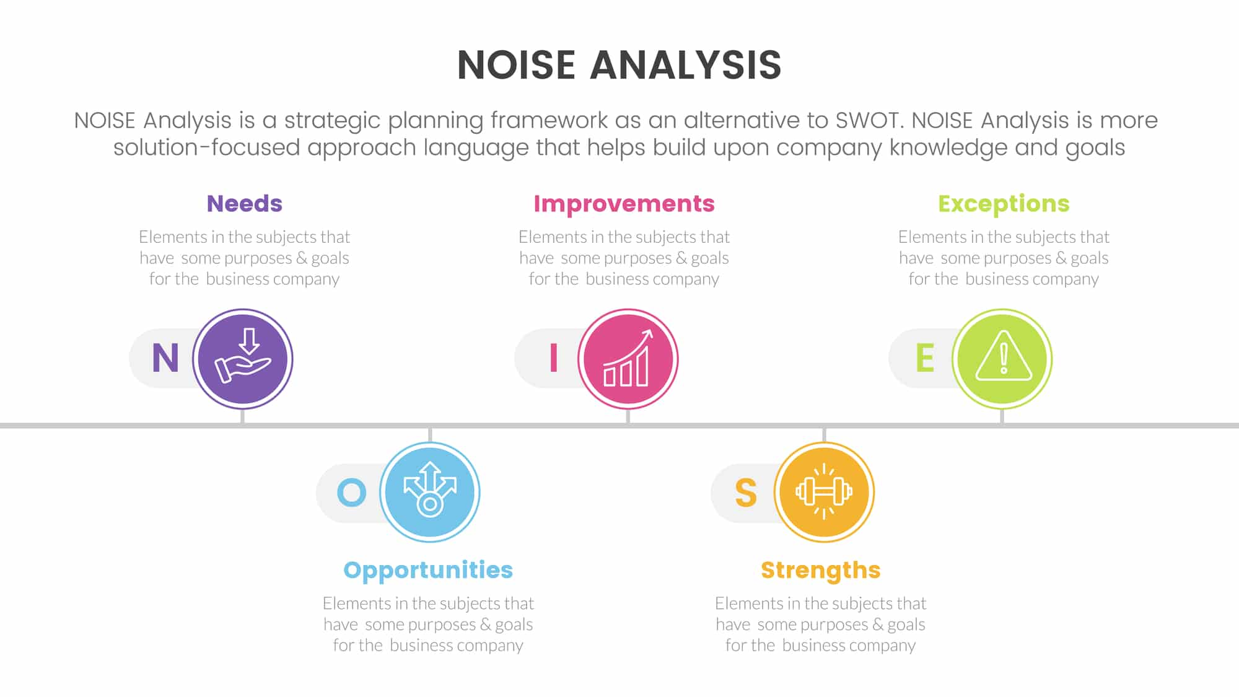

# 1. Identify Competitors:

## Direct:Companies offering similar products/services to the same audience.

## Indirect:Companies offering different products/services that meet the same customer need.

# 2. Gather Information:

## Products/Services:Features, quality, pricing.

## Marketing:Branding, advertising, social media presence.

## Sales:Distribution channels, market share.

## Customer Reviews: Online reviews, feedback.

## Financials: Revenue, profitability (if available).

## SWOT Analysis: Strengths, Weaknesses, Opportunities, Threats.

# 3. Analyze the Data:

## • Compare:

## Identify key differences and similarities.

## Strengths & Weaknesses: Pinpoint areas where competitors excel or fall short.

## Market Positioning: Understand how competitors differentiate themselves.

## Strategies:Determine their approaches to marketing, sales, and product development.

# 4. Key Areas to Focus On:

## Pricing:How do their prices compare to yours?

## Product Differentiation: What makes their products unique?

## Target Market:Who are they trying to reach?

## Customer Experience: How do they interact with customers?

# 5. Tools and Resources:

## Company Websites: Information on products, services, and marketing.

## Social Media: Insights into brand image and customer engagement.

## Industry Reports: Market trends and competitor analysis.

## Online Reviews: Customer feedback and sentiment.

## Financial News: Company performance and strategies.

# Benefits:

## * Identify market opportunities.

## * Improve your own strategies.

## * Stay ahead of the competition.

## *Understand customer needs better.

# Buyer's/ Aduinece’s persona

## A buyer/audience persona is a fictional representation of your ideal customer, based on research and data. It helps you understand their needs, motivations, and behaviors. Here's how to create one:

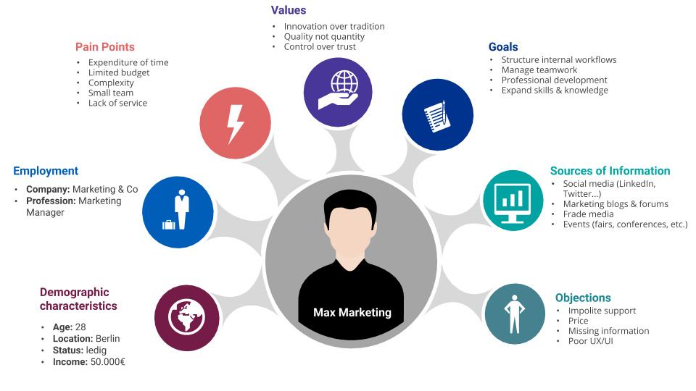

# Research & Data collection key persona Elements:

## Existing Customers: Surveys, interviews, feedback analysis.

## Website Analytics: Demographics, behavior, interests.

## Social Media: Audience insights, engagement patterns.

## Market Research: Industry reports, competitor analysis

# 2.Demographics:

## Age, gender, location, income, education.

## Psychographics:Values, interests, lifestyle, personality.

## Goals & Motivations: What they want to achieve, their driving forces.

## Challenges & Pain Points: Obstacles they face, problems they need to solve.

## Buying Behavior: How they research, where they buy, decision-making process.

## Technology Usage:Preferred devices, social media platforms, online habits.

# 3. Persona Creation:

## Name & Photo:Give your persona a name and find a representative image.

## Story & Background: Create a narrative about their life and work.

## Quotes: Include quotes that reflect their thoughts and feelings.

## Visual Representation: Use a template or tool to create a visual persona profile.

# 4. Example Persona (for a tech product):

## *Name: Tech-Savvy Tina

## * Age: 28

## * Occupation:Software Developer

## * Goals: Stay up-to-date with the latest tech, improve productivity.

## * Challenges:Information overload, finding reliable resources.

## * Buying Behavior: Researches online, reads reviews, prefers trusted brands.

# 5. Benefits of Using Personas:

## *Targeted Marketing: Tailor content and campaigns to specific needs.

## * Product Development: Create products that solve real problems.

## * Improved Customer Experience: Understand and anticipate customer needs.

SEO & KEYWORD RESEARCH



SEO audit:



## Here's a focused SEO audit approach for Noise, considering their market and products:

# 1. Technical SEO:

## Mobile-First Indexing:

## Crucial due to high mobile usage in India.

## Ensure flawless mobile site experience.

## Test with Google's Mobile-Friendly Test.Site Speed:

## * Optimize images (compress, use WebP).

## * Leverage browser caching.

## * Use a CDN.

## * Fast loading is key for e-commerce.

# Crawlability:

## * Check robots.txt and XML sitemap.

## * Fix broken links (404 errors).

## * Ensure clean URL structure.

# HTTPS:

## * Verify secure connection across the entire site.

# 2. On-Page SEO:

## Keyword Optimization:

## * Target relevant keywords: "wireless earbuds," "smartwatch India," "noise cancellation headphones."

## * Optimize product pages with detailed descriptions and keywords.

## * Use long-tail keywords for specific product searches.

# Content Quality:

## * Create informative blog posts: product comparisons, tech guides.

## * Optimize product descriptions with relevant keywords and features.

## * Add user generated content like reviews, and Q&A sections.

# Title Tags & Meta Descriptions:

## * Write compelling titles and descriptions for each page.

## * Include relevant keywords and calls to action.

# Image Optimization:

## * Use descriptive alt text for all product images.

## * Compress images for faster loading.

# Internal Linking:

## * Link related products and blog posts.

## * Improve site navigation.

# 3. Off-Page SEO:

# Backlink Analysis:

## * Analyze the quality and quantity of backlinks.

## * Identify and disavow toxic backlinks.

* Focus on earning high-quality backlinks from relevant websites.

# Social Signals:

## * Maintain an active social media presence.

## * Encourage social sharing of content.

# Online Reviews:

## * Monitor and respond to customer reviews on platforms like Amazon, Flipkart, and Google.

## * Encourage satisfied customers to leave reviews.

# 4. Content Strategy:

# Blog Content:

## * Create content that addresses customer needs and interests.

## * Focus on product reviews, comparisons, and how-to guides.

## * Create video content for product demonstrations, and reviews.

# •Product Pages:

## * Provide detailed product information and specifications.

## * Include high-quality images and videos.

## * Add comparison charts.

# 5. Local SEO (If applicable):

# Google My Business:

## * Claim and optimize Google My Business listing.

## * Ensure accurate NAP (name, address, phone number) information.

# Tools:

## * Google Search Console

## * Google Analytics

## * SEMrush/Ahrefs

## * Screaming Frog SEO Spider

## * PageSpeed Insights

# Key Focus for Noise:

# E-commerce Optimization: Product pages, checkout process.

## Mobile Experience:Given the dominance of mobile users.

## Competitive Keywords:Target keywords related to their specific product lines.

## Brand Building:Use SEO to reinforce brand awareness and credibility.

# KEYWORD RESEARCH:

## Keyword research is the foundation of a successful SEO strategy. It involves identifying the words and phrases people use when searching for information online, and then using those keywords to optimize your website content. Here's a breakdown of the process:

# Why Keyword Research Matters:

## Understanding You Audience:** It reveals what your target audience is searching for, allowing you to create content that meets their needs.

## Driving Organic Traffic: Optimizing your website for relevant keywords helps it rank higher in search engine results, increasing organic traffic.

## Improving Content Strategy: It helps you identify topics and content ideas that are relevant to your audience.

## Gaining Competitive Insights: It allows you to see what keywords your competitors are targeting.

# Key Steps in Keyword Research:

# 1. Define Your Goals:

## What are you trying to achieve with your website?

## What products or services do you offer?

## Who is your target audience?

# 2. Brainstorm Seed Keywords:

## * Start with broad terms related to your business.

## * Think about the words and phrases your target audience might use.

# 3. Use Keyword Research Tools:

## Google Keyword Planner: Provides keyword ideas and search volume data.

## SEMrush: Offers comprehensive keyword research and competitor analysis.

Ahrefs: Provides in-depth backlink and keyword data.

## Moz Keyword Explorer: Offers keyword suggestions and difficulty scores.

# 4. Analyze Keyword Data:

## Search Volume: How often a keyword is searched.

## Keyword Difficulty: How competitive a keyword is.

## Search Intent: The reason behind a user's search.

# 5. Identify Long-Tail Keywords:

## These are longer, more specific phrases that have lower search volume but higher conversion rates.

# 6. Analyze Competitor Keywords:

## See what keywords your competitors are ranking for.

# 7. Organize Your Keywords:

## Group keywords into relevant topics and themes.

# 8. Integrate Keywords into Your Content:

## Use keywords naturally in your website content, including titles, headings, and body text.

## Important Considerations:

## Search Intent: Focus on understanding the user's intent behind each keyword.

## Relevance: Choose keywords that are highly relevant to your website content.

## Competition: Balance high search volume with manageable competition.

## By following these steps, you can conduct effective keyword research and improve your website's SEO performance.

## ON PAGE OPTIMIZATION

## On-page optimization involves refining elements within your website to improve search engine rankings and user experience. Here's a breakdown of key areas:

# 1. Content Optimization:

## High-Quality Content: Create informative, engaging, and relevant content that satisfies user intent.

## Keyword Usage: Naturally incorporate target keywords in titles, headings, body text, and image alt text.

## Content Structure: Use headings (H1-H6), lists, and paragraphs to improve readability.

## Multimedia: Include images, videos, and infographics to enhance content.

## User Experience (UX):Ensure content is easy to read, navigate, and share.

# 2. Title Tags and Meta Descriptions:

## Title Tags: Create concise, keyword-rich titles that accurately reflect page content.

## Meta Descriptions: Write compelling descriptions that encourage clicks from search results.

## Keyword Integration: Include relevant keywords in both title tags and meta descriptions.

# 3. URL Optimization:

## Descriptive URLs: Use clear, concise URLs that include target keywords.

## URL Structure: Create a logical URL structure that reflects site hierarchy.

## Hyphens:Use hyphens to separate words in URLs.

# 4. Header Tags (H1-H6):

## Hierarchy: Use header tags to create a clear content hierarchy.

## Keyword Usage:Include target keywords in header tags where appropriate.

## Readability:Break up content with subheadings for better readability.

# 5. Image Optimization:

## Alt Text: Add descriptive alt text to images for accessibility and SEO.

## File Size:Compress images to reduce file size and improve page speed.

## File Names:Use descriptive file names that include relevant keywords.

# 6. Internal Linking:

## Link Structure:Create a logical internal linking structure to improve site navigation.

## Anchor Text: Use relevant anchor text to link to other pages on your site.

## User Experience: Help users discover related content and improve site engagement.

# 7. Mobile Optimization:

## Responsive Design: Ensure your website is responsive and conmobile-friendly.

## Page Speed:Optimize page speed for mobile devices.

## Touch-Friendly: Design for touchscreens with easy-to-tap buttons and links.

# 8. Page Speed Optimization:

## Image Compression: Compress images to reduce file size.

## Browser Caching: Leverage browser caching to improve loading times.

## CDN: Use a content delivery network (CDN) to distribute content globally.

# Tools:

## * Google Search Console

## * Google PageSpeed Insights

## * Yoast SEO (WordPress plugin)

* SEMrush/Ahrefs

## By focusing on these on-page optimization techniques, you can improve your website's search engine rankings and provide a better user experience.

# CONTACT IDEAS AND MARKETING STRATEGIES

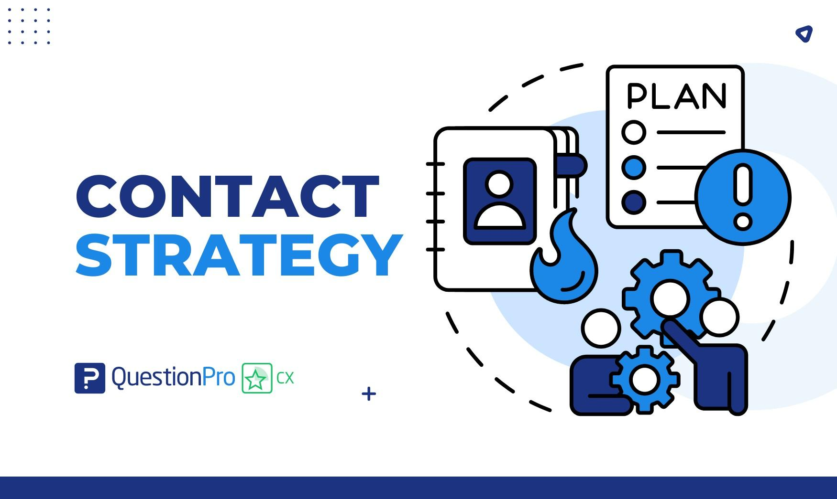

## Contact ideas generation & strategy

## Here's a breakdown of content ideas and strategies tailored for Noise, focusing on their audio and wearable tech products:

# Content Pillars:

## Product Showcases & Reviews:

## Detailed video reviews of new earbuds, smartwatches, etc.

## "Unboxing" and "First Impressions" content.

## Comparison videos: Noise vs. competitors, different Noise models.

## User-generated reviews and testimonials.

# Lifestyle & Fitness:

## Workout playlists using Noise earbuds.

## Fitness challenges and tracking with Noise smartwatches.

## Content on health and wellness, highlighting smartwatch features.

## Collaborations with fitness influencers.

# Tech & Innovation:

# Explanations of audio technology (noise cancellation, etc.).

## "How-to" guides for using smartwatch features.

## Behind-the-scenes content on product design and development.

## Tech trend analysis related to wearables and audio.

# Entertainment & Music:

## Artist collaborations and sponsored playlists.

## Content related to music genres and listening experiences.

## "Soundtrack your day" ideas using Noise products.

## Social media contests related to music and sound.

# Community & Engagement:

## Q&A sessions with product experts.

## User-generated content contests (photos, videos).

## Polls and surveys to gather audience feedback.

## Livestreams with product demonstrations.

Content Strategies:

# Video-First Approach:

## Short-form videos for social media (TikTok, Instagram Reels).

## Long-form videos for YouTube (reviews, tutorials).

## Live video for product launches and Q&A sessions.

# Influencer Marketing:

## Partner with tech, fitness, and lifestyle influencers.

## Focus on authentic product reviews and demonstrations.

## Run influencer-driven contests and giveaways.

# User-Generated Content (UGC):

## Encourage customers to share photos and videos of their Noise products.

## Feature UGC on social media and website.

## Run contests to incentivize UGC creation.

# SEO-Driven Content:

## Create blog posts and articles targeting relevant keywords.

## Optimize product pages for search engines.

## Build backlinks through guest blogging and outreach.

# Social Media Engagement:

## Run interactive polls, quizzes, and contests.

## Respond to comments and messages promptly.

## Use relevant hashtags to increase visibility.

# Personalization:

## Use data to personalize email and social media marketing.

## Create content that caters to specific audience segments (fitness enthusiasts, music lovers, etc.).

# Seasonal Campaigns:

## Create content around holidays, festivals, and seasonal events.

## Offer special promotions and discounts during these periods.

# Key Considerations:

## * Target Audience:Tailor content to the specific needs and interests of Noise's target audience.

## * Brand Voice: Maintain a consistent brand voice across all content channels.

## * Call to Action: Include clear calls to action in all content (e.g., "Shop Now," "Learn More").

## * Analytics: Track content performance and make adjustments as

MARKETING STRATEGY

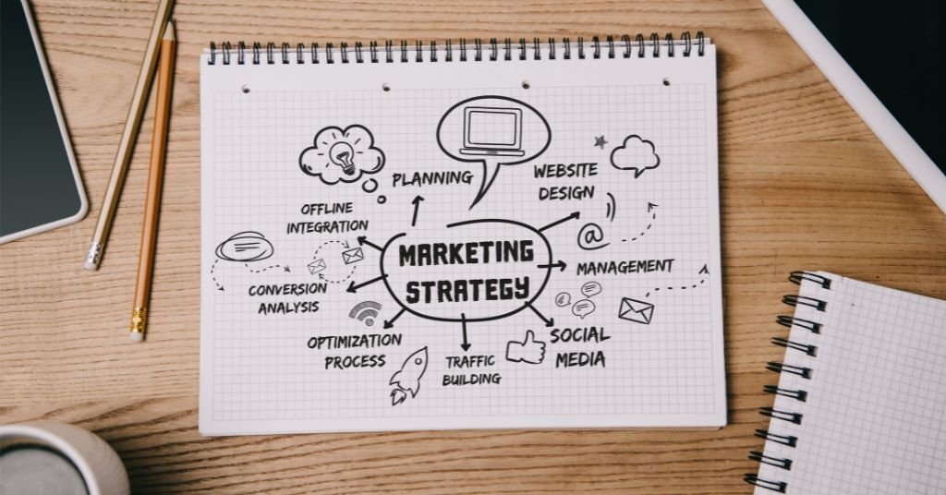

## A solid marketing strategy outlines how a business will achieve its marketing goals. Here's a breakdown of key components:

# 1. Define Your Target Audience:

## Create detailed buyer personas.

## Understand their demographics, psychographics, needs, and pain points.

## 2. Set Clear Marketing Objectives:

## • Increase brand awareness.

## • Generate leads.

## • Drive sales.

## •Improve customer loyalty.

## • Objectives should be SMART (Specific, Measurable, Achievable, Relevant, Time-bound).

# 3. Develop a Unique Value Proposition (UVP):

## • What makes your product or service different from competitors?

## • Clearly communicate the benefits to your target audience.

# 4. Choose Marketing Channels:

# Digital Marketing:

## • SEO (Search Engine Optimization)

## • Content Marketing

## • Social Media Marketing

## • Email Marketing

## • Paid Advertising (PPC, Social Ads)

# • Traditional Marketing:**

## • Print Advertising

## • TV/Radio Advertising

## • Direct Mail

## • Events and Trade Shows

# 5. Create a Content Strategy:

## • Develop a content calendar.

## • Create high-quality, engaging content that aligns with your target audience's interests.

## • Content formats: blog posts, videos, infographics, social media posts.

# 6. Develop a Social Media Strategy:

## • Choose the right platforms for your target audience.

## • Create a consistent brand voice and visual identity.

## • Engage with your audience and build a community.

# 7. Implement an SEO Strategy:

## • Conduct keyword research.

## • Optimize website content and structure.

## • Build high-quality backlinks.

# 8. Implement an Email Marketing Strategy:

## • Build an email list.

## • Segment your audience.

## • Create personalized email campaigns.

# 9. Implement a Paid Advertising Strategy:

## • Choose the right platforms and ad formats.

## • Target your ads to your ideal customer.

## • Track and optimize your campaigns.

# 10. Set a Marketing Budget:

## • Allocate resources to different marketing channels.

## • Track your ROI (Return on Investment).

# 11. Measure and Analyze Results:

## • Use analytics tools to track key metrics.

## • Analyze your results and make adjustments to your strategy as needed.

# 12. Stay Agile and Adapt:

## •The marketing landscape is constantly changing.

## • Be prepared to adapt your strategy to new trends and technologies.

CONTENT CREATION AND CURATION

## Content creation involves producing original content, while content curation is the process of gathering and sharing existing content from various sources, adding value through organization or commentary. ess

# Posters creatio :

## •Comprehensive digital marketing for noise

